Impressions of 38th Chinna Shodha Yatra
Praveen Kumar Reddy

Every CSY is a lifetime experience for whoever attends it, this time 38th CSY, it was a wonderful experience with people of different age groups varying below Ten years and above Seventy. Every yatri has a distinct knowledge on how to contribute to the society and are making a commendable dent in their areas of expertise.
CSY is a mobile library of knowledge where many books are exchanged, everyone reads every book, where each book has its own significance.

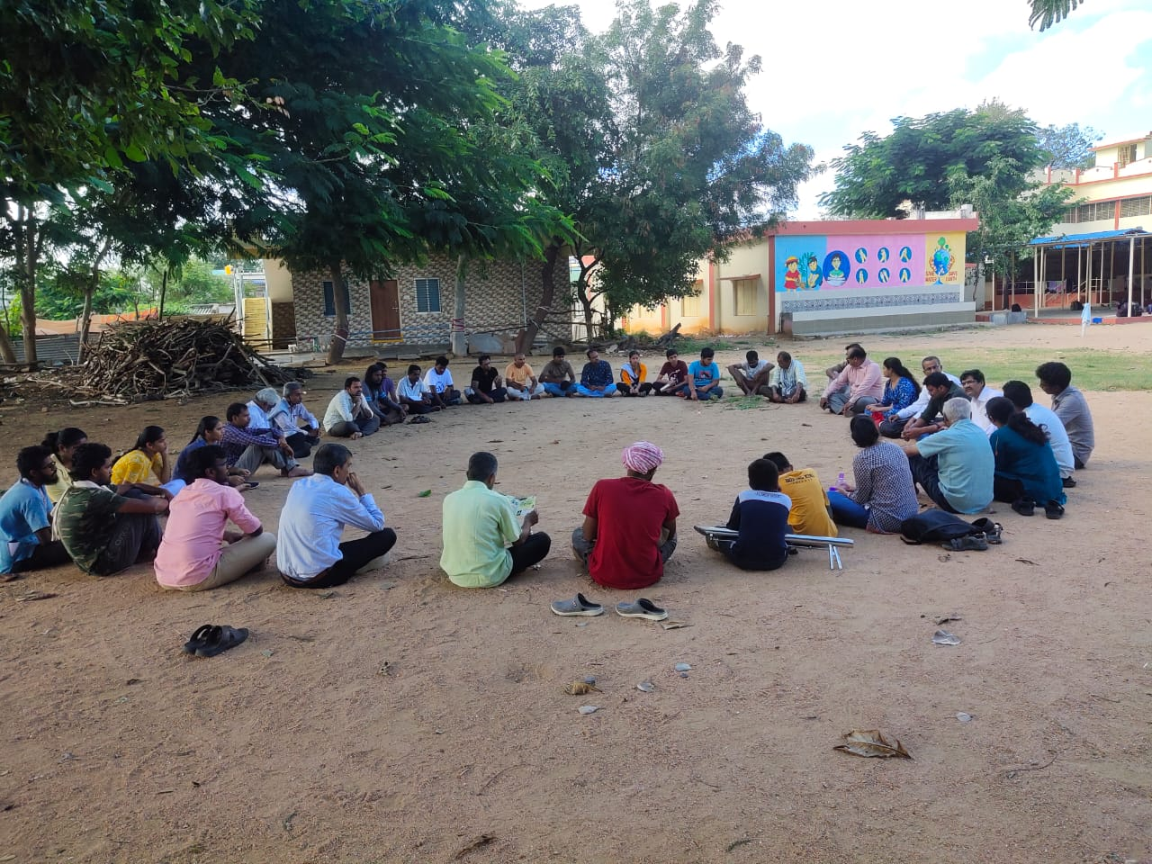

Each and every second is a valuable moment during the yatra and lived it fully by interacting with Nature, People, Experiences. I have learnt how to observe things at the Micro level which is much needed to find out the real-world problems. In this era of technological innovations in this fast-paced world, Grass root innovations need to be supported on a large scale so that there can be a clear visual impact on the lives of many people who are in need of them.

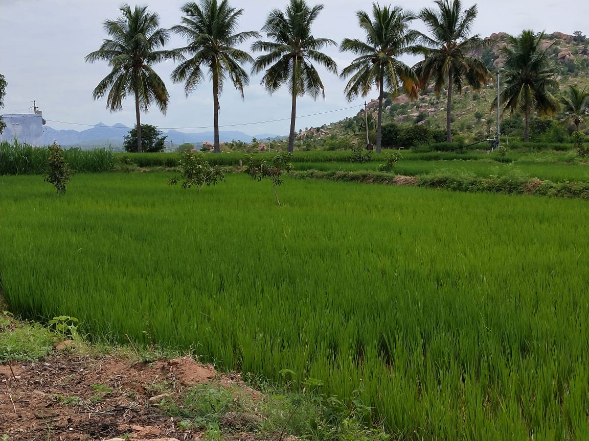

As said, "Patience is the key to success", at the Grass root level innovators, it has to be a mountain of patience for the innovator to show his product to the world, make them reach the point of actual problems to be solved. Creating a product solving the real-life difficulties faced with a limited set of resources and technology is a mammoth task and it's even more difficult to Market the product in the real world.

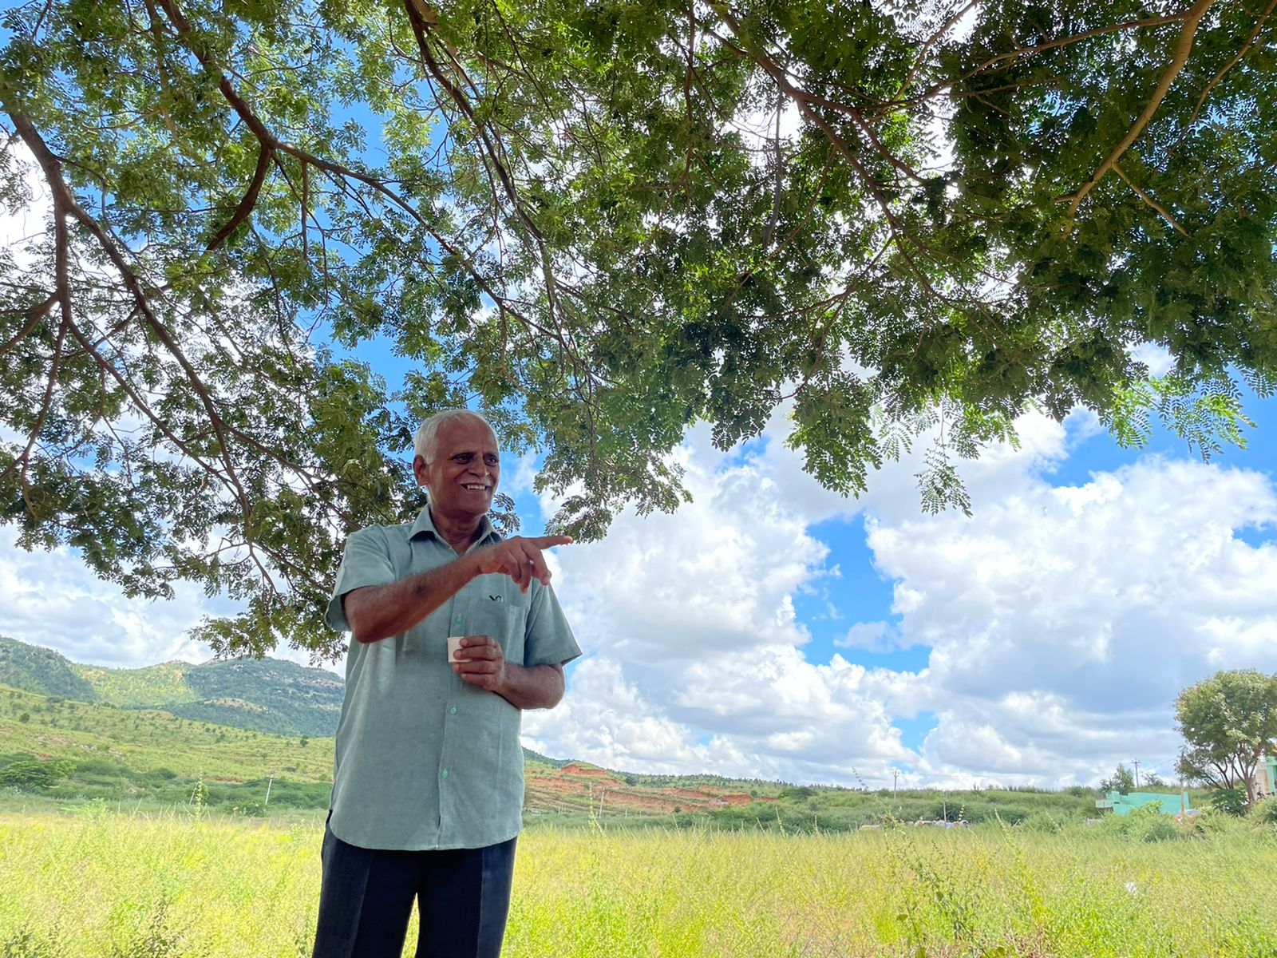

Last but not the least, Thanks to the Strong and Energetic person Brigadier P Ganesham garu, who is paving a way for people like us to know about the environment of the villages and support the future Grass root innovators.

Thanks & regards,
Praveen Kumar Reddy.

